Texas FFA
State Officer Selection Process
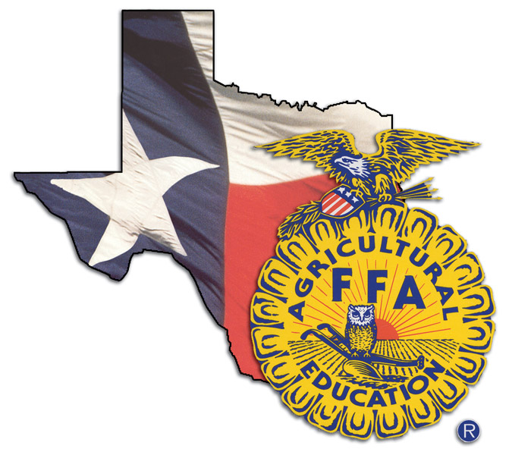
State Officer Selection Process
Preparation Workshops

Anyone interested in the new State FFA Officer selection process – Potential Candidates, Future State Officer Candidates, Area Officer Candidates, FFA Advisors, Parents and anyone else interested in how to prepare for the new process.

February 14Texas Tech University Lubbock
February 21James Madison High School San Antonio
March 7George West High School George West
March 21Chester Nimitz High School Houston
March 28Tarleton State University Stephenville
April 4Gilmer High School Gilmer
April 11Tarleton State University Stephenville

9:00 a.m. until 4:00 p.m.

WHO

WHEN
&
WHERE

TIME

This workshop will concentrate on preparing State FFA Officer Candidates for the 2015 selection process. Time will be spent on each of the rounds including: test, writing exercise, personal round: introduction, stand and deliver, facilitation, round robin and personal round: conclusion. We will also discuss the logistics of what will be happening during the selection process and will answer any questions that you may have.

Workshop Facilitator: Dr. David Frazier – Supervisor of the new process
If you have questions regarding the workshops, contact Dr. Frazier at frazier@tarleton.edu
Register on judgingcard.com
There is NO registration fee; however, you will be responsible for your own lunch!
You may register and attend one or all of these workshops.
What will you need at the workshop?
You will need to bring a copy of the state officer handbook (available online at Texas FFA), paper to take plenty of notes and a positive attitude!!

